**Cisco Secure Client Installation Procedure**

**Version 1**

Contents

Purpose 3

Scope 3

Steps 3

Installation Verification 4

# Purpose

This procedure instructs on how to install Umbrella Cisco Secure client on end user’s devices.

# Scope

ETS internal and external clients

# Steps

1. Copy and paste installation folder (Provided by ETS SOC) on device’s C drive.
2. Installation folder should have below (or similar) files.

1. Now Run Command Prompt as an admin and switch to a file path where Installation package folder has been saved.

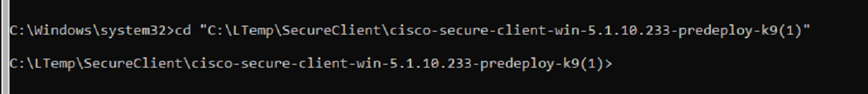

1. Now run the following 3 commands one by one. Please make sure that the software version you have matches with the command.

msiexec /package cisco-secure-client-win-5.1.10.233-core-vpn-predeploy-k9.msi PRE_DEPLOY_DISABLE_VPN=1 /norestart /passive /lvx* vpninstall.log

msiexec /package cisco-secure-client-win-5.1.10.233-umbrella-predeploy-k9.msi PRE_DEPLOY_DISABLE_VPN=1 /norestart /passive /lvx* umbrellainstall.log

msiexec /package cisco-secure-client-win-5.1.10.233-dart-predeploy-k9.msi /norestart /passive /lvx* dartinstall.log

1. Commands should run without any error messages.

# Installation Verification

1. Open “Service” on target device and you should see following 3 services populated and running.



1. To verify if Umbrella Policies are being applied to this device or not, please visit test domain “[http://examplemalwaredomain.com](http://examplemalwaredomain.com/)”
2. You should see below (or similar) block page if installation was successful.

**Revision History:**

|  |  |  |
| --- | --- | --- |
| Revision Date | Action | Author |
| 07/10/2025 | Initial Document | Kaushal Patel |